**NETWORK ARCHITECTURE – I**

**HOMEWORK #2**

**Name : Shreyaa Sridhar**

**Student ID : 16251190**

**Email ID :** [ssn2m@mail.umkc.edu](mailto:ssn2m@mail.umkc.edu)

**Question 1**

Suppose from your computer, you clicked to obtain a web page from a remote server. The web page contains nine very small objects. Let *RTT0* denote the RTTs between your computer and the remote server. Ignoring processing, queuing and transmission delay, how much time is required for the client to receives the full web page using

1. Non-persistent HTTP?
2. Persistent HTTP?

**Answer**

Given number of objects is 9 .

**Case 1: Non-persistent HTTP**

In Non-Persistent HTTP, one RTT0 for establishing TCP connection, one RTT0 to receive the web page and one RTT0 for each object. Here the connection is closed after an object is received, so we need to establish connection for each object.

Time taken to establish connection = 1 RTT0

|  |  |  |  |  |
| --- | --- | --- | --- | --- |
| Time Taken for the web page or base file to reach the client | = | Time taken to establish connection | + | Time taken to request and receive web page |
|  | = | 1 RTT0 + 1 RTT0 = 2 RTT0 |  |  |

Since connection is closed after base file is received, connection needs to be established for every object.

|  |  |  |  |  |
| --- | --- | --- | --- | --- |
| Time taken for one object | = | Time taken to establish connection | + | Time taken to request and receive one object |
|  | = | 1 RTT0 + 1 RTT0 = 2 RTT0 |  |  |

|  |  |  |
| --- | --- | --- |
| Time taken for nine objects | = | Number of Objects (Time taken for one object) |
|  | = | 9 ( 2 RTT0 ) = 18 RTT0 |

|  |  |  |  |  |
| --- | --- | --- | --- | --- |
| Time taken to receive full web page (base file+ 9 objects) | = | Time Taken for the web page or base file to reach the client | + | Time taken for nine objects |
|  | = | 2 RTT0 + 18 RTT0 = **20 RTT0** |  |  |

**Case 2: Persistent HTTP without Pipelining**

In Persistent HTTP, one RTT0 for establishing TCP connection, one RTT0 to receive the web page and one RTT0 for each object. Here TCP connection is kept open even after an object was sent. Since there are nine objects,

Time taken to establish connection = 1 RTT0

|  |  |  |  |  |
| --- | --- | --- | --- | --- |
| Time Taken for the web page or base file to reach the client | = | Time taken to establish connection | + | Time taken to request and receive web page |
|  | = | 1 RTT0 + 1 RTT0  = 2 RTT0 |  |  |

|  |  |  |  |  |
| --- | --- | --- | --- | --- |
| Time taken for one object | = | Time Taken for the web page or base file to reach the client | + | Time taken to request and receive one object |
|  | = | 2 RTT0 + 1 RTT0 = 3 RTT0 |  |  |

|  |  |  |  |  |
| --- | --- | --- | --- | --- |
| Time taken to receive full web page (base file+ 9 objects) | = | Time Taken for the web page or base file to reach the client | + | Time taken to request and receive nine objects |
|  | = | 2 RTT0 + 9 RTT0 = **11 RTT0** |  |  |

**Case 3: Persistent HTTP with Pipelining**

In Persistent HTTP, one RTT0 for establishing TCP connection, one RTT0 to receive the web page and one RTT0 for all objects pipelined. Considering all the nine objects are pipelined and since TCP connection is kept open even after an object is received, it will take as little as one RTT for all the referenced objects. Since there are nine objects,

Time taken to establish connection = 1 RTT0

|  |  |  |  |  |
| --- | --- | --- | --- | --- |
| Time Taken for the web page or base file to reach the client | = | Time taken to establish connection | + | Time taken to request and receive web page |
|  | = | 1 RTT0 + 1 RTT0 |  |  |
|  | = | 2 RTT0 |  |  |

|  |  |  |  |  |
| --- | --- | --- | --- | --- |
| Time taken for one object | = | Time Taken for the web page or base file to reach the client | + | Time taken to request and receive one object |
|  | = | 2 RTT0 + 1 RTT0 = 3 RTT0 |  |  |

|  |  |  |  |  |
| --- | --- | --- | --- | --- |
| Time taken to receive full web page (base file+ 9 objects) | = | Time Taken for the web page or base file to reach the client | + | Time taken to request and receive nine objects (considering all nine objects were pipelined) |
|  | = | 2 RTT0  + 1 RTT0 |  |  |
|  | = | **3 RTT0** |  |  |

**Question 2**

Explain elaborately the procedure of registering domain names and ip address for your start-up company (what companies to contact, how much is the fee, etc.).

**Answer**

First, I would **check the availability of the domain name** which one wants to name as. There are several online based tools to check the availability of the domain name.

Second, if the domain name is not used and is available the next step to do is **find registrar**. For making the registrar choice, it is advised to do some research on different registrar. User can also check the availability of the domain name on domain registering website like **Register.com, Namecheap.com, BlueHost.com** or **GoDaddy.com**.

Third, the domain name registrar would **register the static IP addresses and names** of the servers in the TLD server available such as **.com, .org, .net or .edu.**

Fourth, each registrar has different prices to charge for registering names and their prices may vary significantly. The prices for domain names vary among different registrars and hosting companies. Brand new domains will cost about **$10-15 a year**, depending on registrar and TLD. The domain name should be renewed periodically.

Few examples of different Registrars and their pricing,

|  |  |  |  |  |
| --- | --- | --- | --- | --- |
| Registrar | .com | .net | .org | .edu |
| GoDaddy.com | $14.99/yr | $18.99/yr | $19.99/yr | $24.99/yr |
| Namecheap.com | $10.98/yr | $12.98/yr | $12.98/yr | $16.88/yr |
| Register.com | $5.00/yr | $5.00/yr | $5.00/yr | $5.00/yr |

Finally, after completing these steps the domain name are registered and a user can access the webpage from anywhere by entering the website name.

**Question 3: Laboratory Homework**

**Part 1: Telnet experiments**

Try HTTP request (GET, HEAD, or POST) without using a web-browser. You can do this on command line using ‘> telnet ***webserver***80’. (for example web server can be: [www.umkc.edu](http://www.umkc.edu), however, you are free to choose any webserver) Record the HTTP responses from the server – retrieve at least two different response status (for example: 200, 301 or any other valid response you prefer) from the server.

**Answer**

**Case 1: Method = GET, Status code = 200 and Response Phrase = OK**

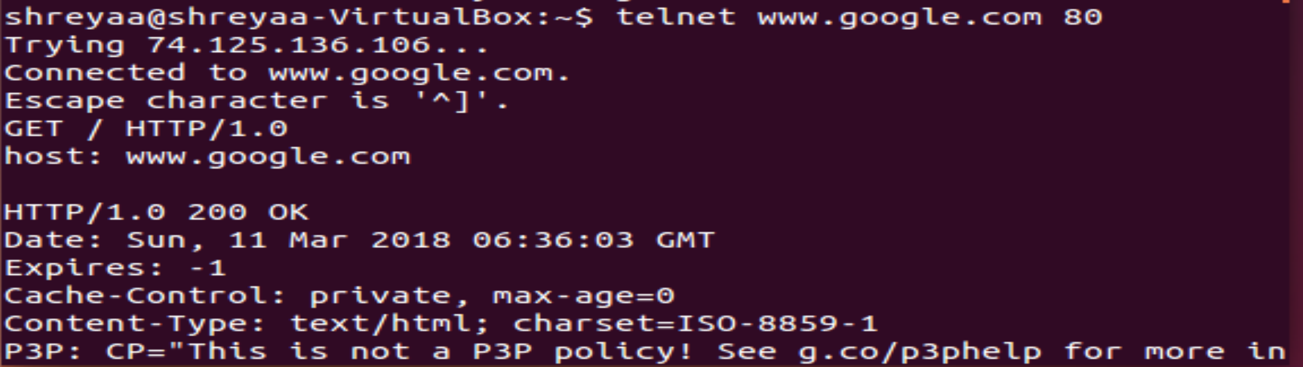

**Case 2: Method = GET, Status Code = 301 and Response Phrase = Moved Permanently**

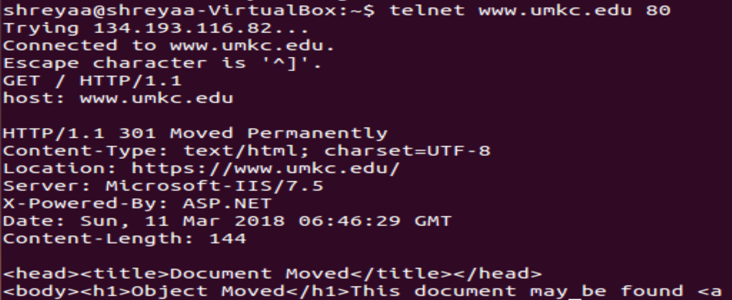

**Case 3: Method = GET, Status Code = 404 and Response Phrase = Not Found**

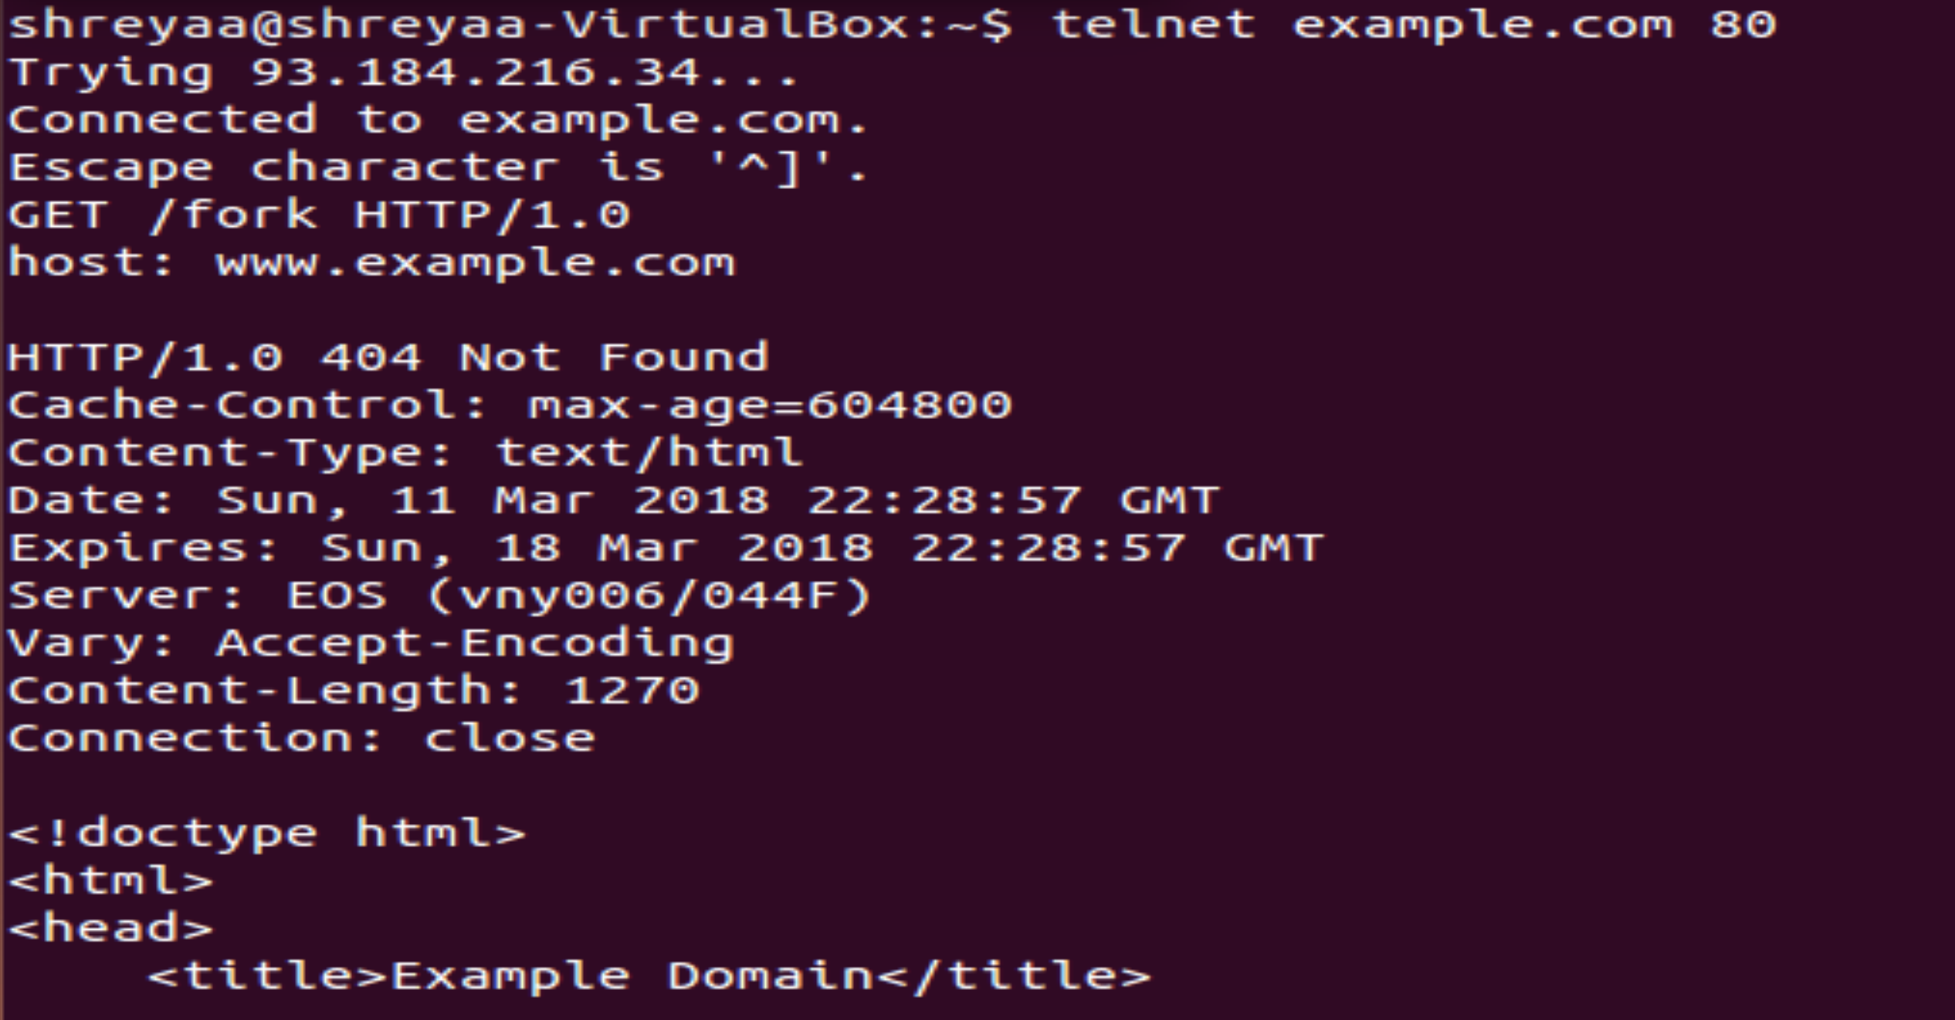

**Case 4: Method = GET, Status Code = 400 and Response Phrase = Bad Request**

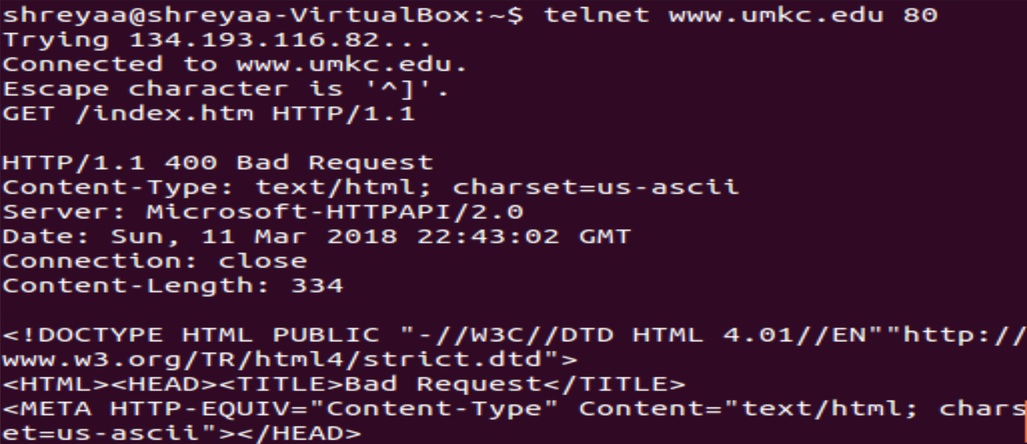

**Case 5: Method = HEAD, Status code = 200 and Response Phrase = OK**

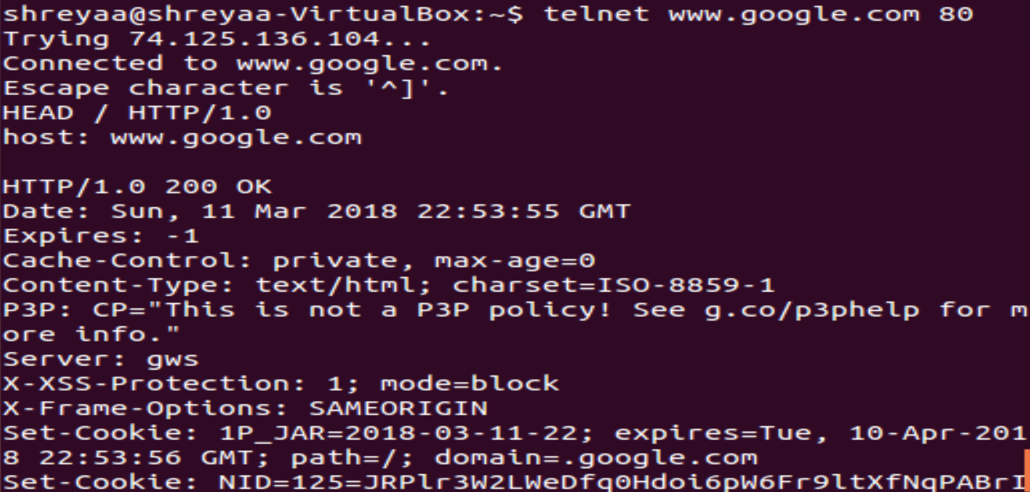

**Case 6: Method = HEAD, Status Code = 301 and Response Phrase = Moved Permanently**

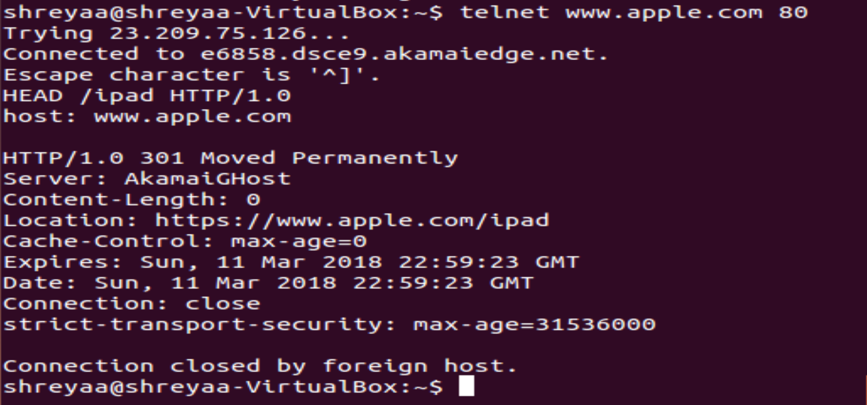

**Case 7: Method = HEAD, Status Code = 404 and Response Phrase = Not Found**

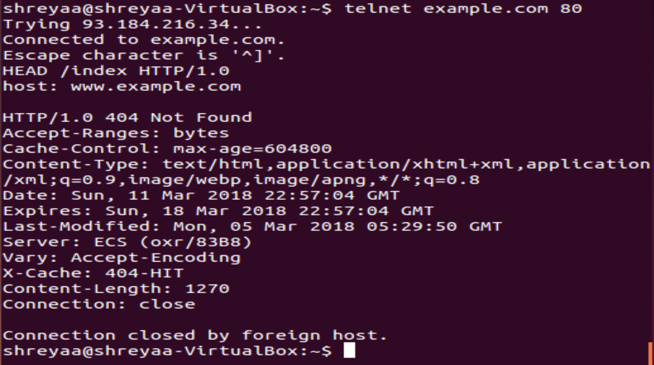

**Case 8: Method = HEAD, Status Code = 400 and Response Phrase = Bad Request**

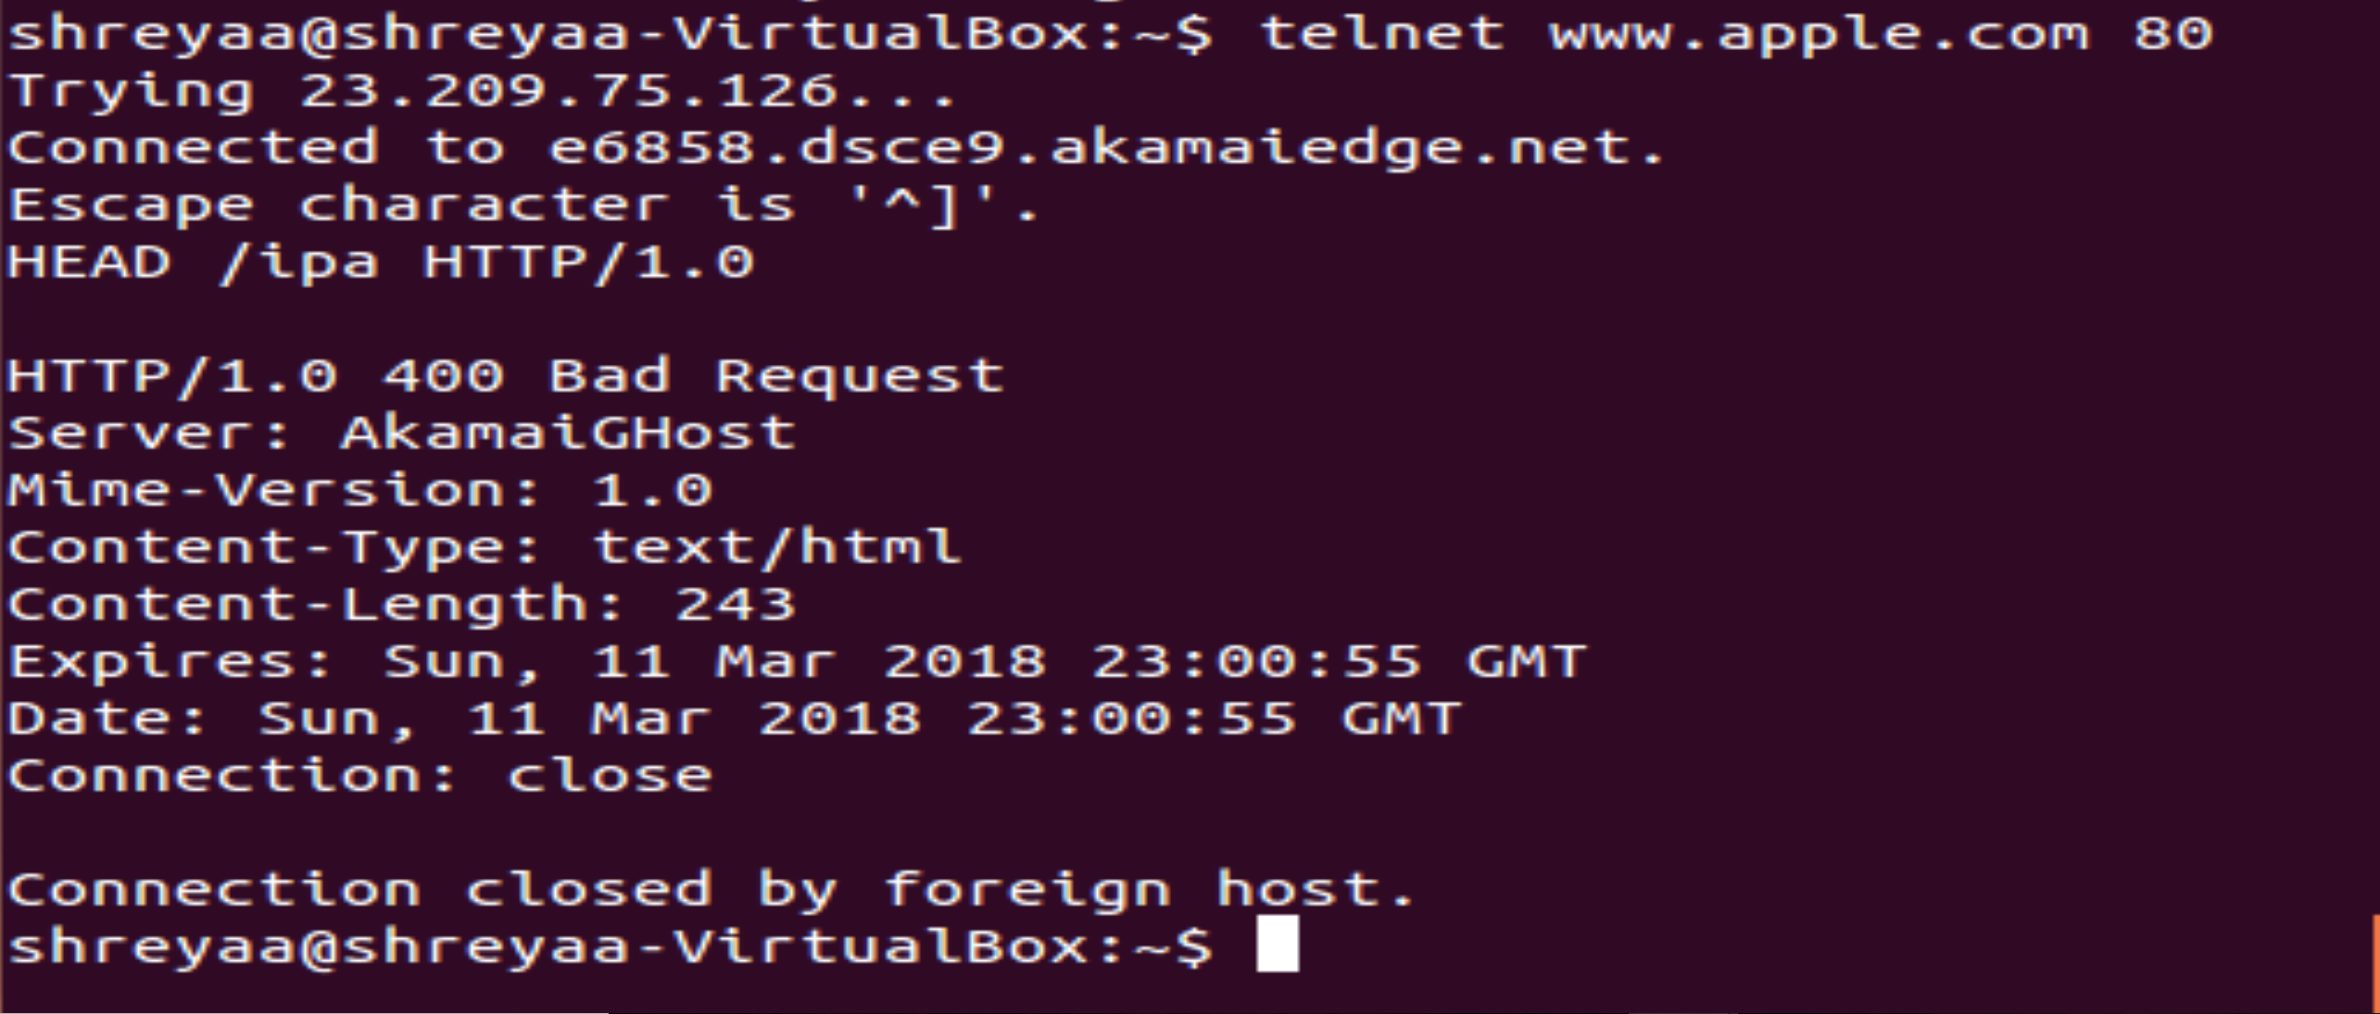

**Part 2: Wireshark experiments**

In this part of the homework, you will use Wireshark to investigate HTTP protocol in operation. In this lab, you’ll explore a couple of aspects of the HTTP protocol: the basic GET/response interaction, and retrieving large HTML files.

Create a trace file on your own following the instruction given below from you home.

1. Start up your web browser.
2. Start up the Wireshark packet sniffer. Enter “http” in the display-filter-specification window, so that only captured HTTP messages will be displayed later in the packet-listing window.
3. Wait a bit for more than one minute and then begin Wireshark packet capture.
4. Enter the following URL to your browser

http://gaia.cs.umass.edu/wireshark-labs/HTTP-wireshark-file1.html

Your browser should display the very simple, one-line HTML file.

1. Stop Wireshark packet capture.

Then, open the trace file on the Wireshark, and answer to the questions below.

**Answer**

First, creating a trace file. Here we are adding a display filter ‘http’ , which displays only Http messages captured.

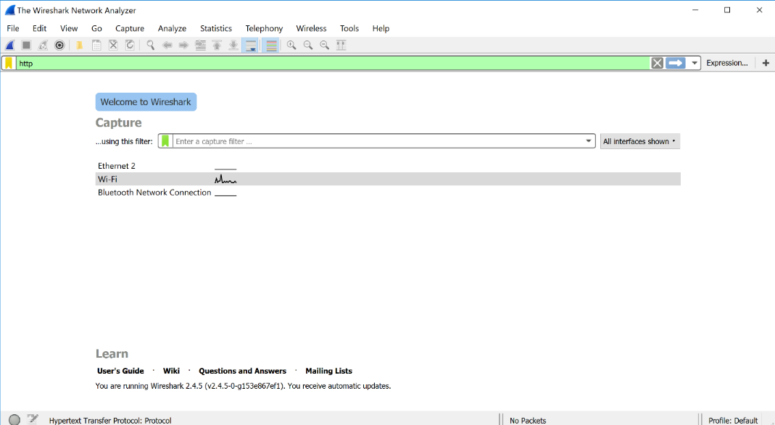

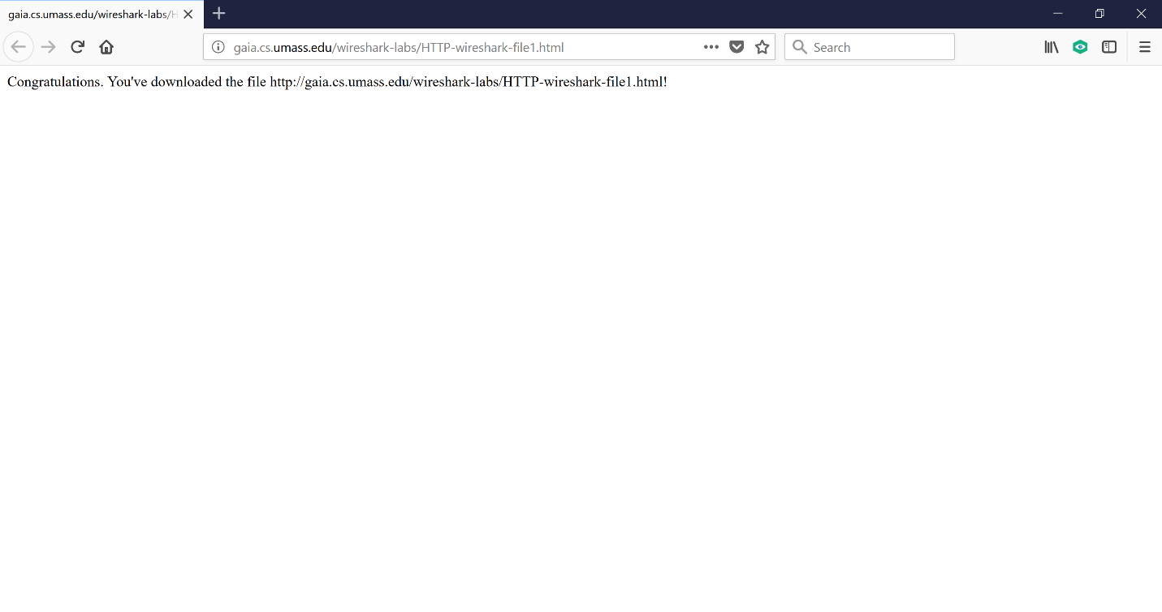

Wireshark shows the packet capture.

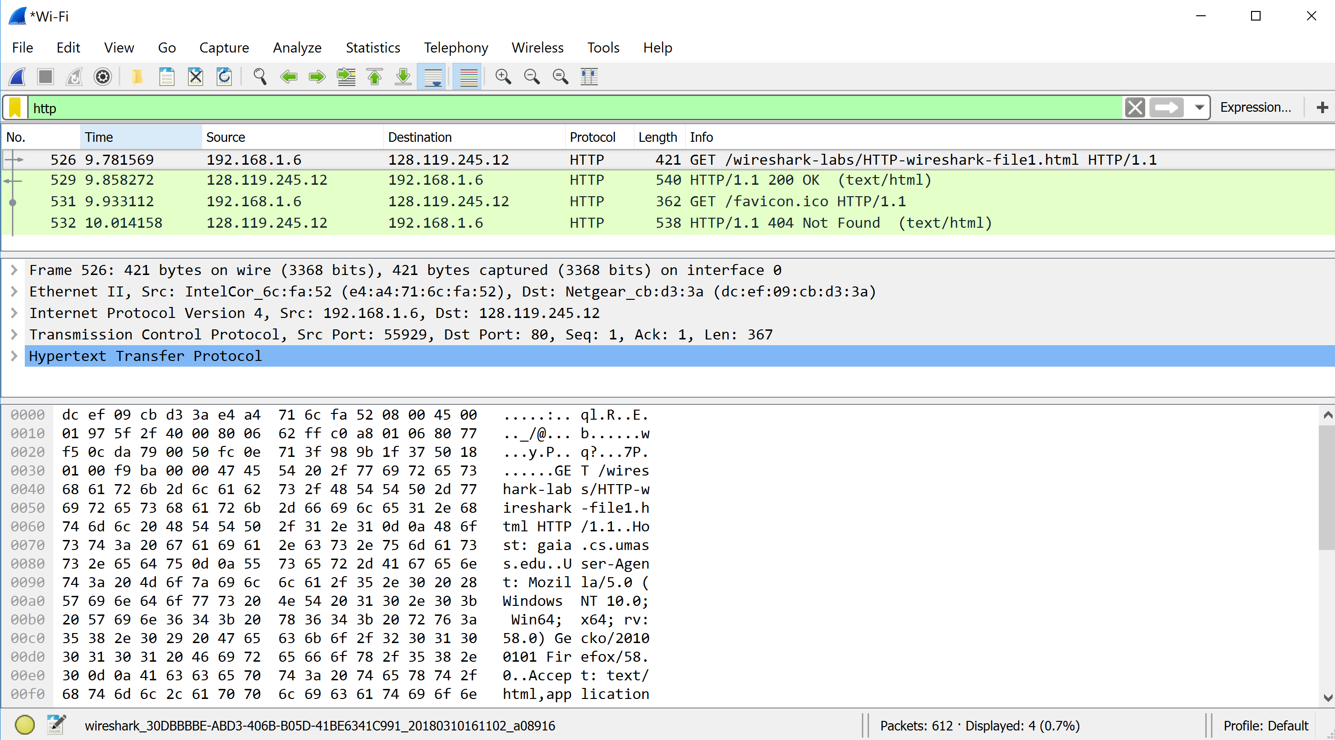

**Part2-1: The Basic HTTP GET/response interaction**

Once you open the trace file, it will show in the packet-listing window that two HTTP messages were captured: the GET message and the response message from the server to your browser. The packet contents window shows details of the selected message. Recall that since the HTTP message was carried inside a TCP segment, which was carried inside an IP datagram, which was carried within an Ethernet frame, Wireshark displays the Frame, Ethernet, IP, and TCP packet information as well. We want to minimize the amount of non-HTTP data displayed, so make sure the boxes at the far left of the Frame, Ethernet, IP and TCP information have a plus sign, and the HTTP line has a minus sign. By looking at the information in the HTTP GET and response messages, answer the following questions. When answering the following questions, you should print out the GET and response messages and indicate where in the message you’ve found the information that answers the following questions.

1. Is your browser running HTTP version 1.0 or 1.1? What version of HTTP is the server running?
2. What languages (if any) does your browser indicate that it can accept to the server?
3. What is the IP address of your computer? Of the gaia.cs.umass.edu server?
4. What is the status code returned from the server to your browser?
5. When was the HTML file that you are retrieving last modified at the server?
6. How many bytes of content are being returned to your browser?
7. By inspecting the raw data in the packet content window, do you see any headers within the data that are not displayed in the packet-listing window? If so, name one.

**Answer**

1. My Browser HTTP version is 1.1

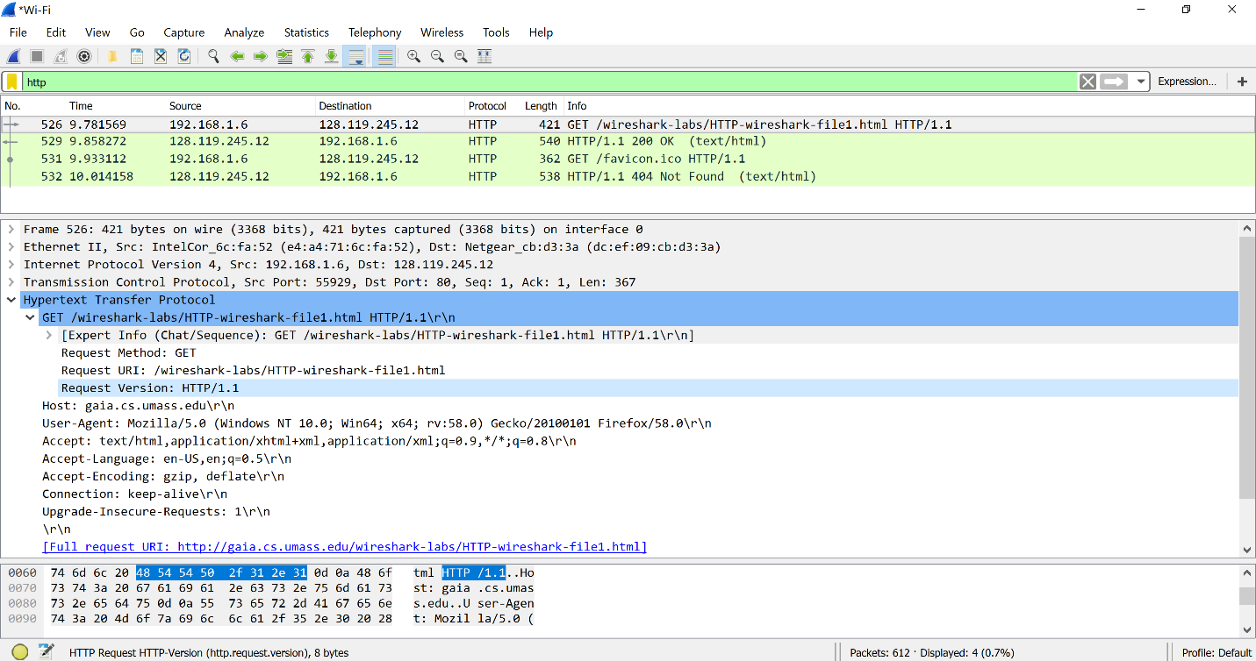

Server HTTP version is 1.1

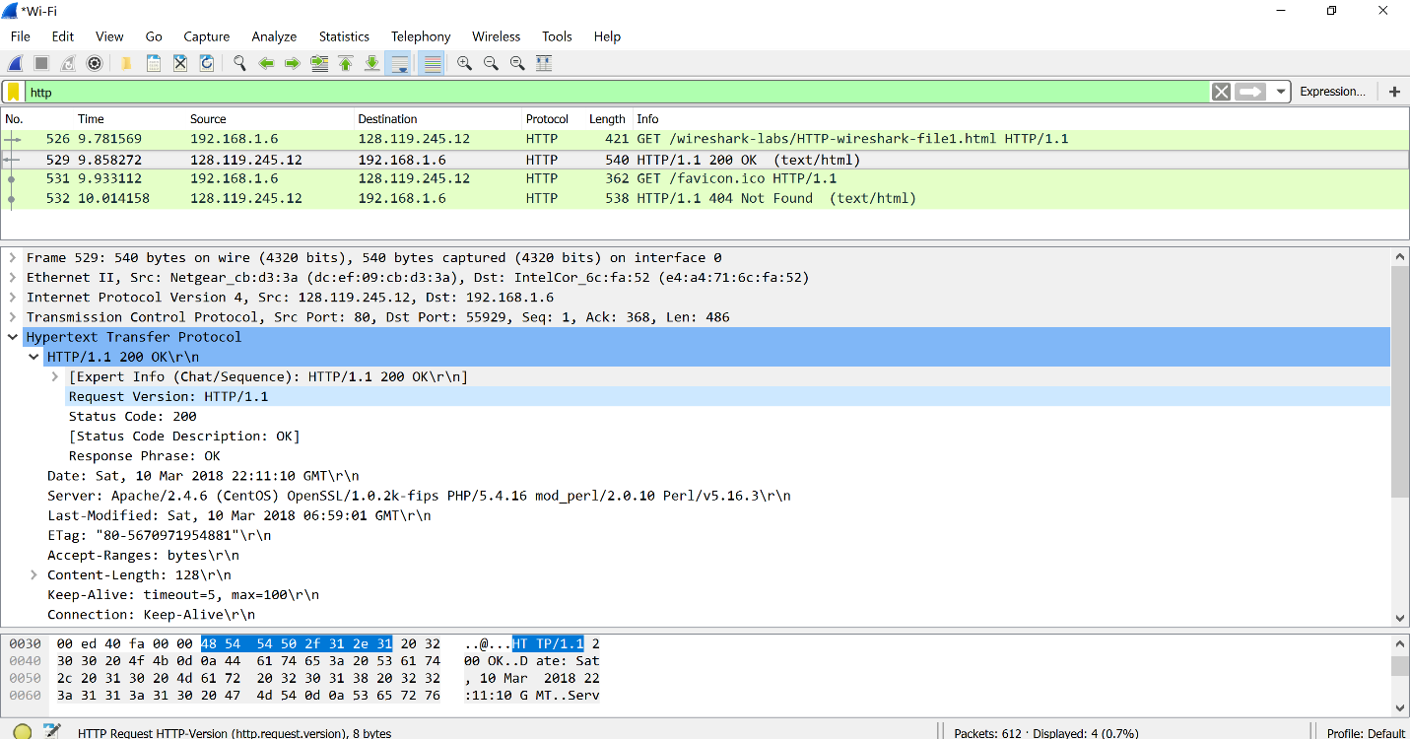

1. Language Accepted is en-US

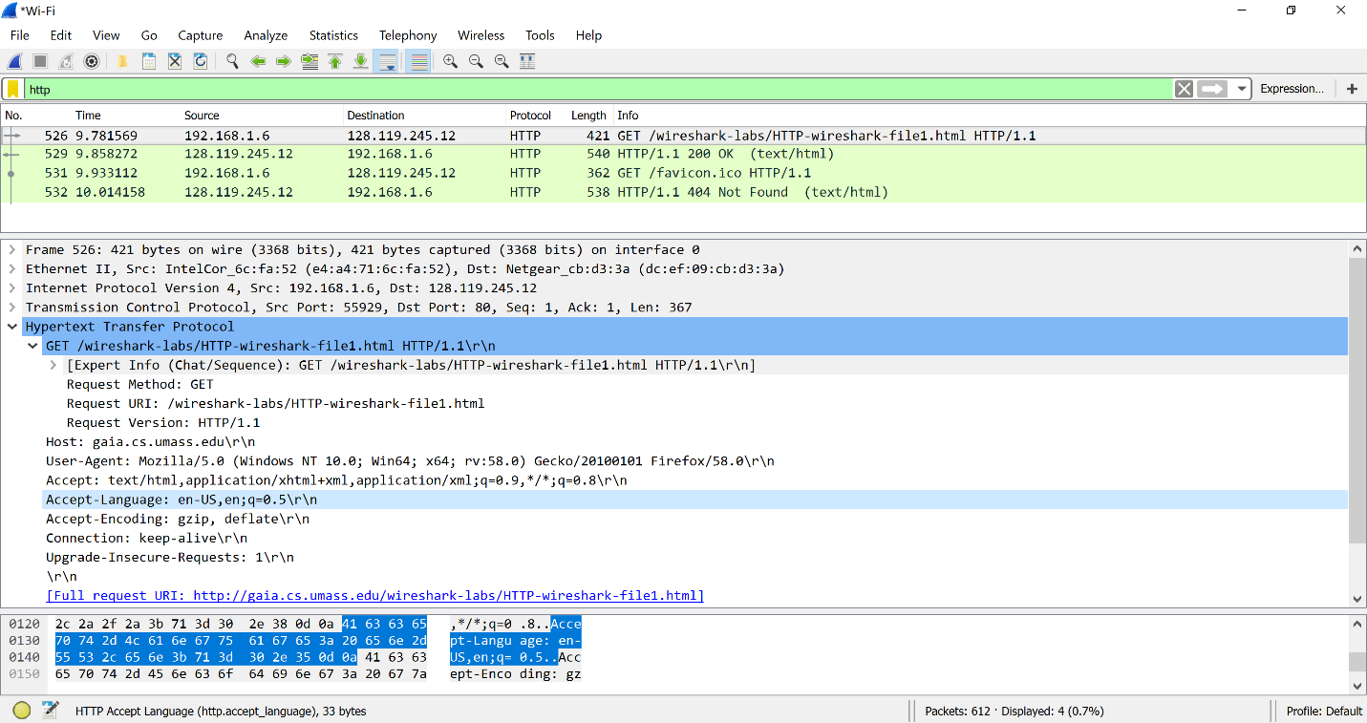

1. IP address of my computer is 192.168.1.6

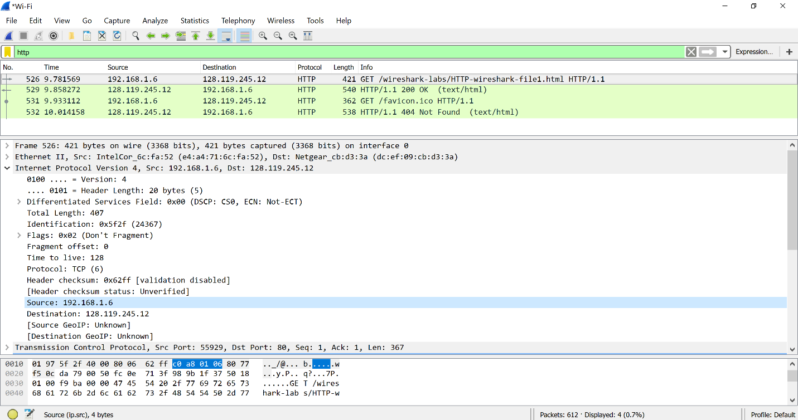

IP address of gaia.cs.umass.edu server is 128.119.245.12

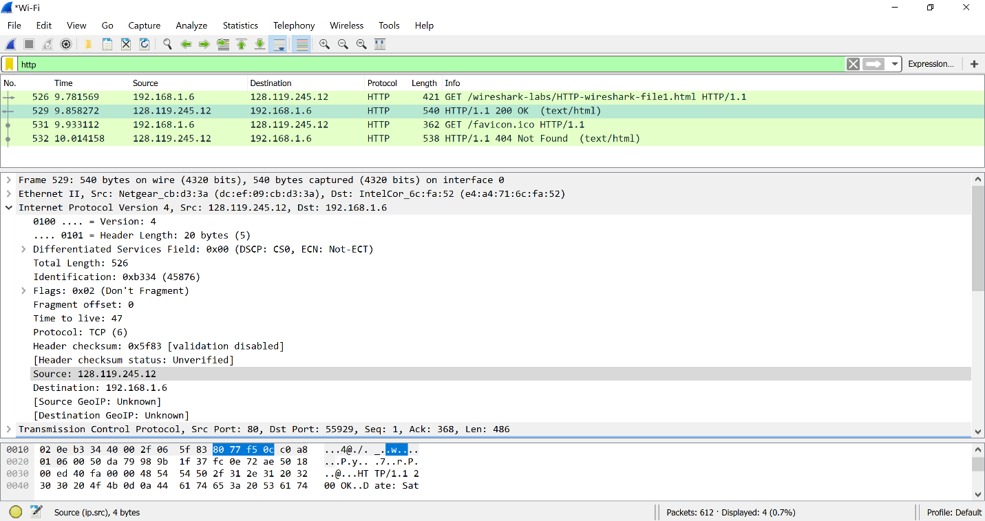

1. Status Code returned from the server to my browser is 200 which stands for OK.

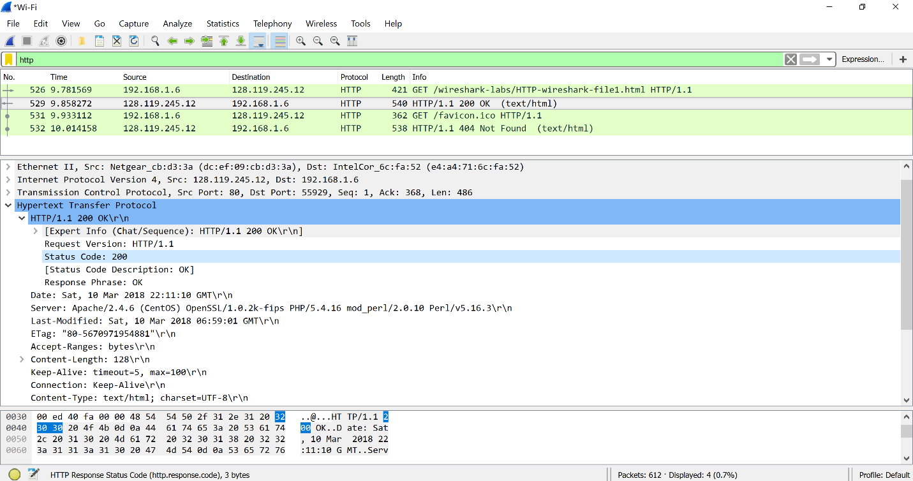

1. The HTML file retrieved was last modified at the server on 10th March 2018 06:59:01 GMT .

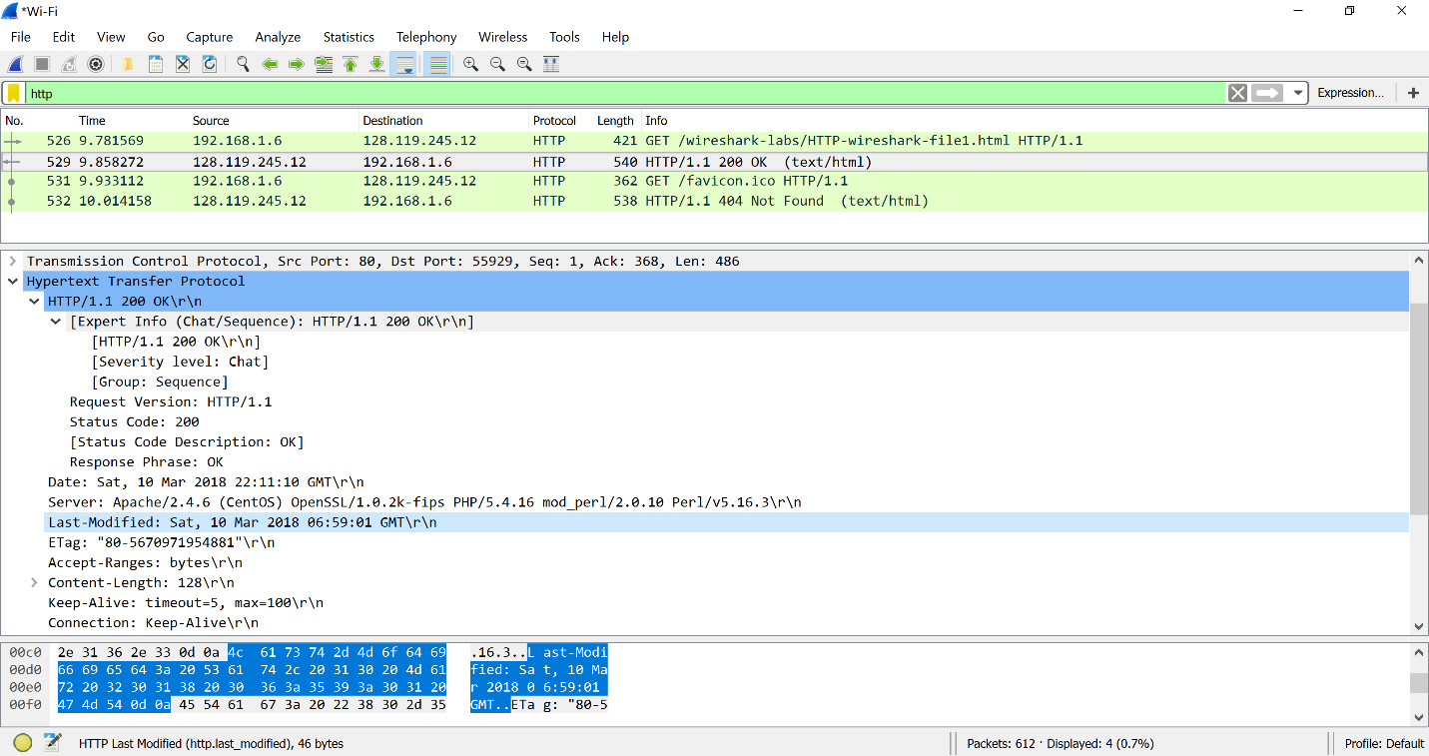

1. 128 bytes of content was returned to my browser.

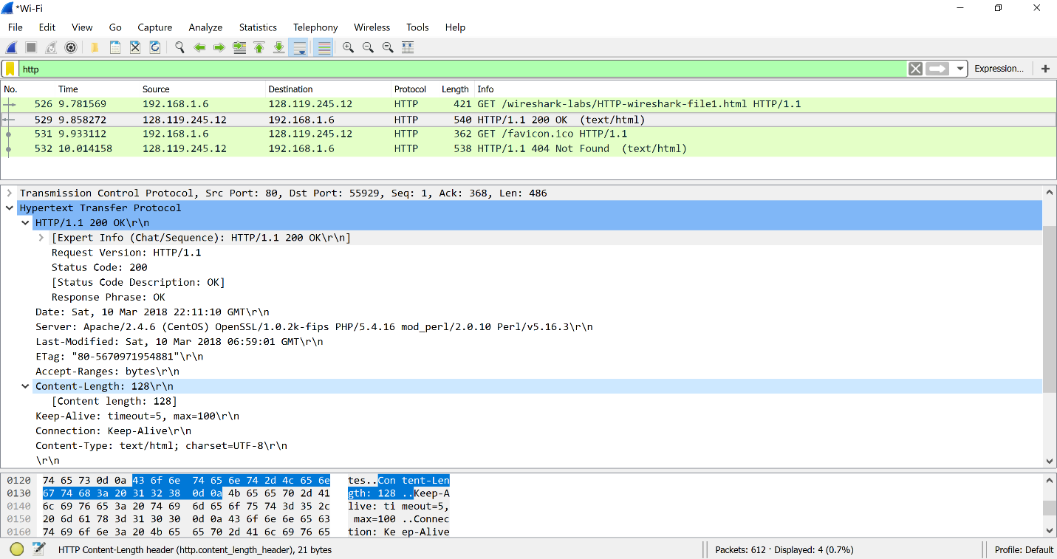

1. No, there is no headers within the data. The raw data appears to match up exactly with what is shown in the packet-listing window.

**Part 2-2: Retrieving Long Documents**

In the previous example, the document retrieved has been simple and short HTML files. Let’s next see what happens when we download a long HTML file.

Create a trace file on your own following the instruction given below from you home.

Start up your web browser, and make sure your browser’s cache is cleared

1. Start up the Wireshark packet sniffer
2. Enter the following URL into your browser

http://gaia.cs.umass.edu/wireshark-labs/HTTP-wireshark-file3.html

Your browser should display the rather lengthy US Bill of Rights.

1. Stop Wireshark packet capture, and enter “http” in the display-filter-specification window, so that only captured HTTP messages will be displayed.

Then, open the trace file on the Wireshark and answer to the questions below.

In the packet-listing window, you should see your HTTP GET message, followed by a multiple packet response to your HTTP GET request. This multiple-packet response deserves a bit of explanation. Recall that the HTTP response message consists of a status line, followed by header lines, followed by a blank line, followed by the entity body. In the case of our HTTP GET, the entity body in the response is the *entire* requested HTML file. In our case here, the HTML file is rather long, and at 4500 bytes is too large to fit in one TCP packet. The single HTTP response message is thus broken into several pieces by TCP, with each piece being contained within a separate TCP segment. Each TCP segment is recorded as a separate packet by Wireshark, and the fact that the single HTTP response was fragmented across multiple TCP packets is indicated by the “Continuation” phrase displayed by Wireshark. We stress here that there is no “Continuation” message in HTTP!

1. How many HTTP GET request messages were sent by your browser?
2. How many data-containing TCP segments were needed to carry the single HTTP response?
3. What is the status code and phrase associated with the response to the HTTP GET request?
4. Are there any HTTP status lines in the transmitted data associated with a TCP induced “Continuation”?

**Answer**

First, creating a trace file. Here we are adding a display filter ‘http’, which displays only Http messages captured.



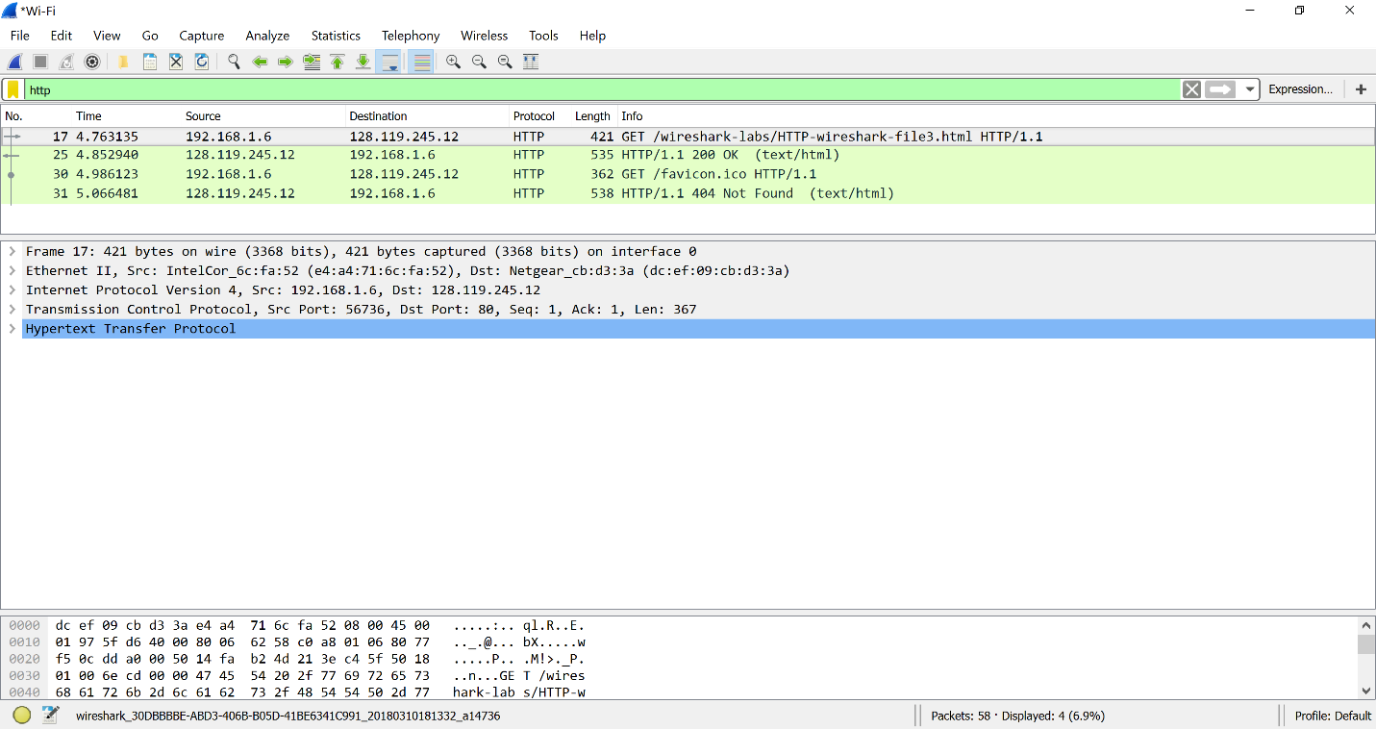

1. Ignoring the favicon.ico, there is just one HTTP request message sent by my browser.

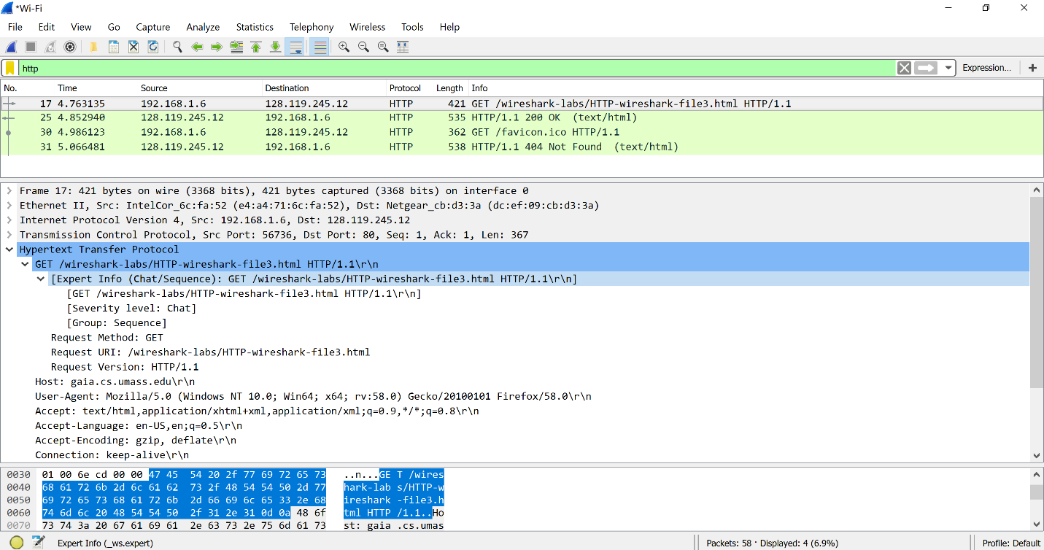

1. There are 4 data containing TCP segments were needed to carry the single HTTP response.

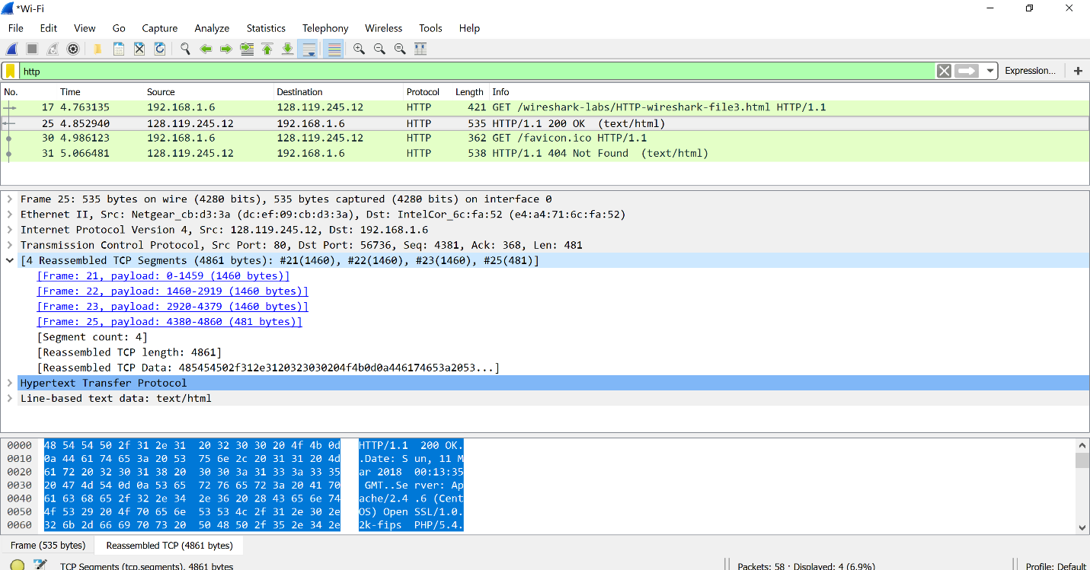

1. Status code is 200 and response phrase is OK.

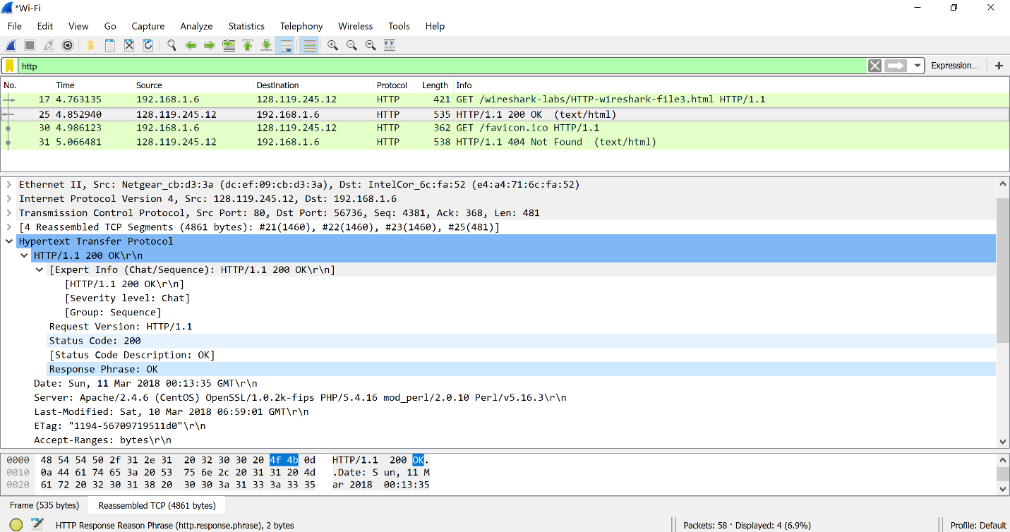

1. No, there are no HTTP status lines in the transmitted data associated with a TCP induced Continuation.

But after unchecking the ‘Allow subdissector to reassemble TCP streams’, it shows Continuation. On seeing the packets number it is after the client receives the file and by ignoring the favicon.ico.

